PARKER COUNTY BURN BAN EFFECTIVE 8/5/2020
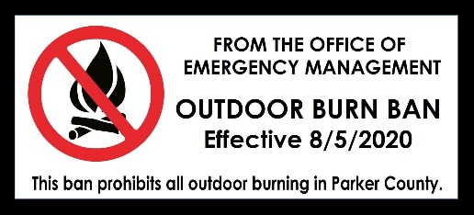
Today, as directed by the Parker County Commissioner’s court on Monday, July 27, 2020, the Parker County Office of Emergency Services, the County Fire Marshal, is implementing an Outdoor Burning Ban for Parker County effective Wednesday, August 5, 2020 at midnight for at least the next 60 days. This ban prohibits all outdoor burning in Parker County with the following exceptions:
>> Domestic wastes that normally result from the function of life within a residence—for example, kitchen garbage, untreated lumber, cardboard boxes, packaging, clothing, grass, leaves, and branch trimmings, may be burned in compliance with the requirements as listed below.
>> Outdoor Cooking allowed in compliance with the requirements as listed below.
>> These prohibitions do not apply to the sale or detonation of fireworks.
>> That involve the performance of outdoor combustible operations, including but not limited to, outdoor welding, cutting or grinding operations by any person if the operations are performed in compliance with the requirements as listed below.
>> Related to public health and safety that are authorized by the Texas Commission on Environmental Quality.
>> Burns that are conducted by a prescribed burn manager certified under Section 153.048, Natural Resources Code, and meet the standards of Section 153.047, Natural Resources Code.
>> Burns authorized by both the Parker County Fire Marshal’s Office and the fire department assigned to provide service to the area in which the burn would take place, then conducted under the direct supervision of that same department.
Currently, the Keetch-Byram Drought Index (KBDI) for Parker County is at 553 and rising. No measureable rain has fallen in Parker and no rain is forecast for the foreseeable future. If the county receives significant rainfall to lower the KBDI, the ban can be suspended as needed.
Any questions can be directed to the Parker County Fire Marshal/Emergency Management Coordinator Sean Hughes @ 817-598-0969 office or sean.hughes@parkercountytx.com.
For full press release with attachments, visit: https://www.parkercountytx.com/DocumentCenter/View/6867/OES-Burn-Ban-for-August-2020-with-attachments

