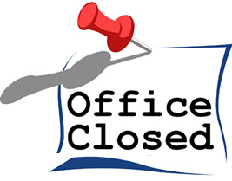

Effective immediately: As of Thursday, March 26, 2020 Cresson City Hall will be closed to the public. Customers are still able to make payments with cash, check, or money order via the drop box on the front gate or via credit card on the city website www.cressontx.org. The staff will be in the office from 8:30 am to 1:00 pm Monday thru Friday. If you have questions, please call us at 817-396-4729. You may reach us via email at cityofcresson@outlook.com, cityofcresson@gmail.com, or cityofcresson@windstream.net. Thank you for your patience and understanding during the Coronavirus pandemic.

